Use Case Diagrams
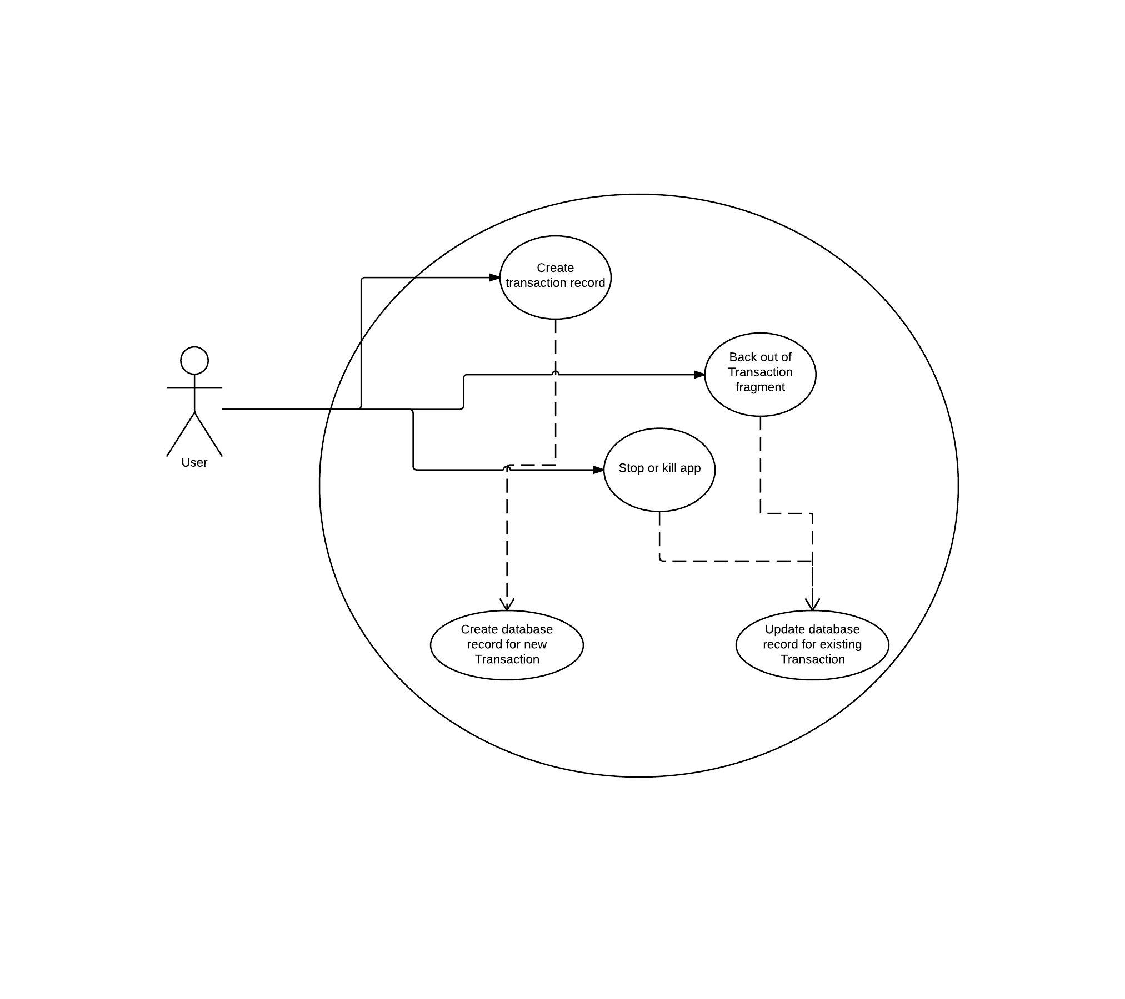Diagram 1: Creating and Updating Transactions

